Practical 5

NAME: TASNEEM SADIKOT
PRN: 23070521162

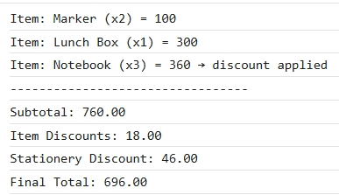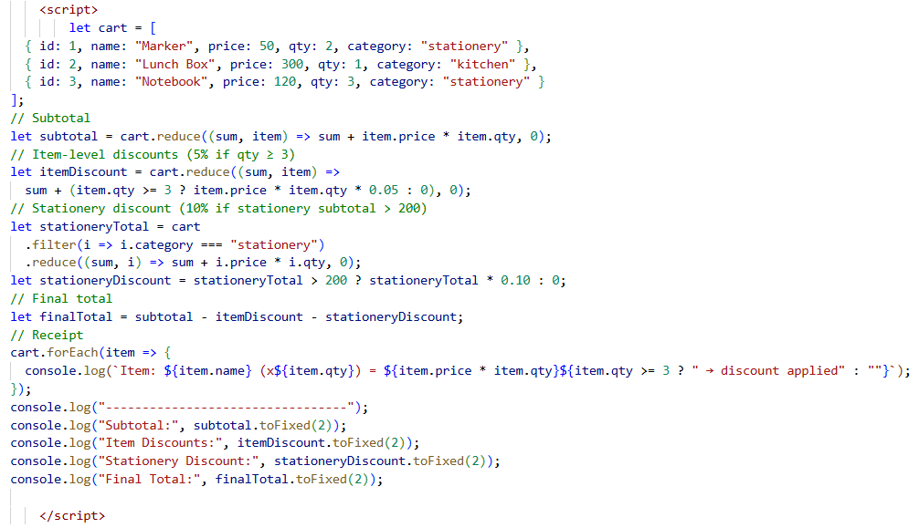

Q1. Which function (map, filter, reduce, forEach) was hardest to apply? Why?
Ans: reduce() was the hardest because it requires keeping track of an accumulator and carefully adding values. Unlike map or filter (which are straightforward), reduce can get confusing if you’re not clear about initial values and the accumulation logic.
Q2. How could this program be extended?
Ans:
- Add tax calculation (e.g., GST at 18%).
- Add coupons or promo codes (e.g., ₹50 off or 15% off total).
- Add shipping charges (free above ₹500, else ₹50).
- Add loyalty points tracking for repeat customers.

let taxRate = 0.18; // 18%
let tax = discountedTotal * taxRate;

let couponCode = "SAVE50"; // try changing to "" to skip
let couponDiscount = 0;
if (couponCode === "SAVE50") couponDiscount = 50; // flat ₹50 off
if (couponCode === "SAVE10") couponDiscount = discountedTotal * 0.10; // 10% off

let shipping = discountedTotal > 500 ? 0 : 50;

